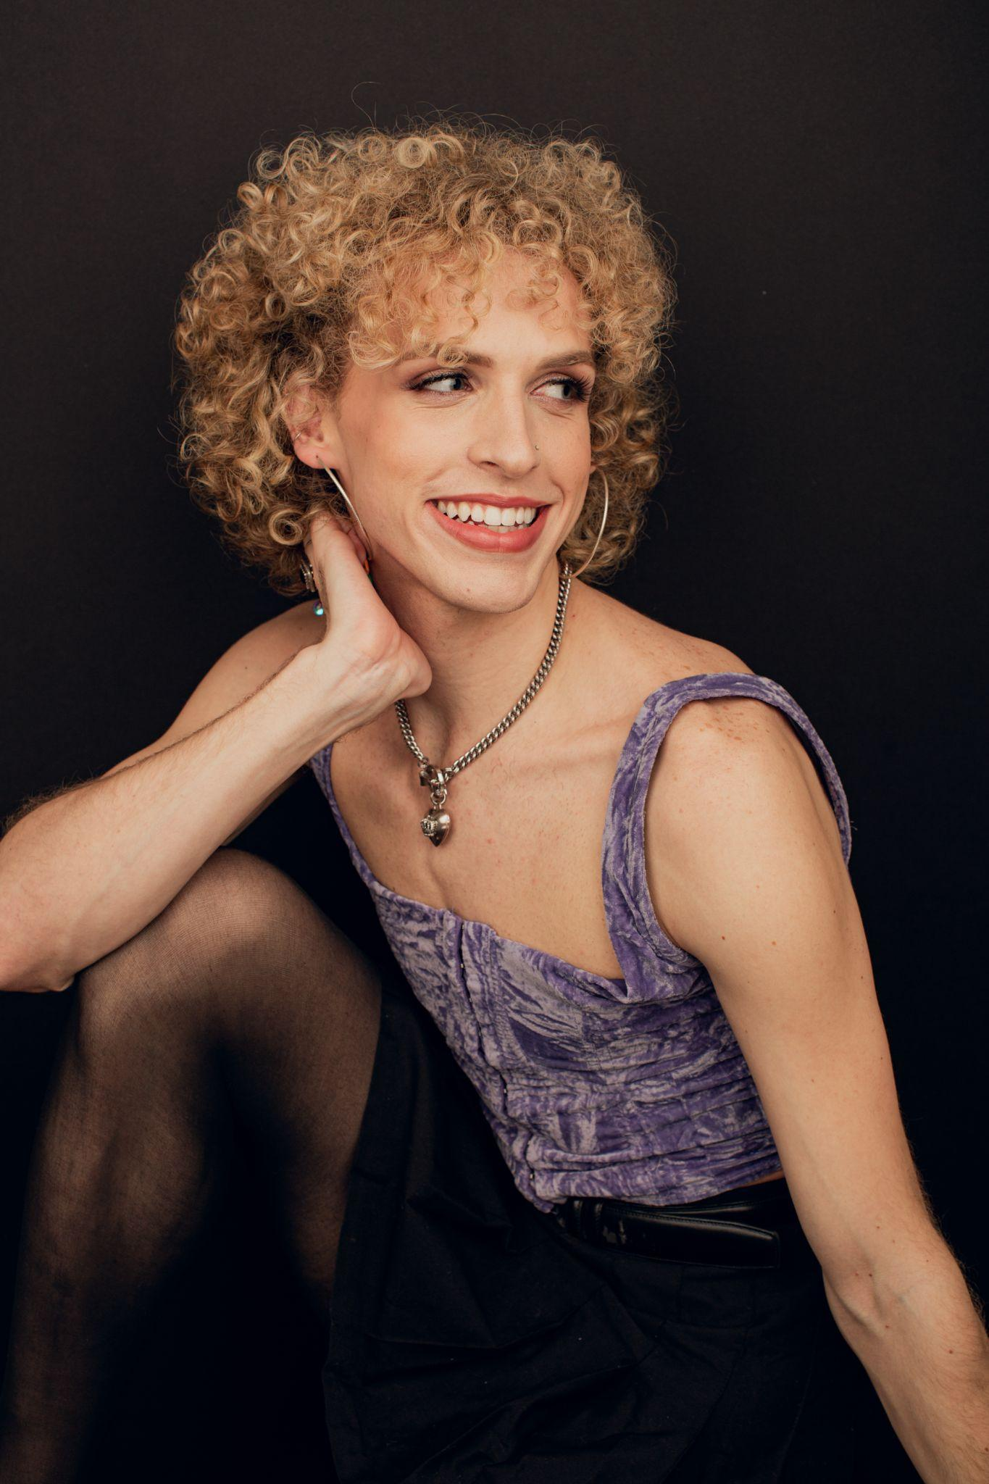
T h e o B r o w n
EMC & SAG Eligible
she/her
5’9
Blue Eyes Blonde Hair
(847) 337-5119
theobrown2400@gmail.com
Theobrown.info
______________________________________________________________________________________________________

Regional Theatre
Chasing Grace White Tessa/Ens. JAG Productions (Dawn Simmons)
Be More Chill (Chicago Premier) Michael Mell Stage Door Fine Arts (Paula Taylor)
Donkey Show (Closing Cast) Peaseblossom Fairy American Repertory Theater (Taylor Brennan)
Spring Awakening Ernst Weathervane Repertory Theatre (Marisa Kirby)
… Spelling Bee Leaf Coneybear Stage Door Fine Arts
The Curious Incident… Christopher u/s Weathervane Repertory Theatre (Cady Huffman)
Bright Star Max Weathervane Repertory Theatre (Ethan Paulini)
White Christmas Dance/Tap Ensemble Weathervane Repertory Theatre
Sister Act Featured Dancer Weathervane Repertory Theatre

Educational Theatre
Head Over Heels Pythio (intimacy captain) Boston Conservatory (Larry Sousa)
BoCo Sings Sondheim Johanna soloist Boston Conservatory (Paul Daigneault, David Coleman)
Body Maps Original Devised Piece Boston Conservatory (Tim Miller)
Mr. Burns, a Post-Electric Play Marge Simpson/Troy Boston Conservatory (Amanda Friou)
Macbeth Porter/Ensemble Boston Conservatory

Film & TV Work
Julia Lucille Ball waitress HBO Max (Charles McDougall)
__________________________________________________________________________________________________________________________________

Training
The Boston Conservatory at Berklee College of Music- BFA ‘22 with an emphasis in directing and devising
Acting: Laura Marie Duncan, Jennie Israel, Doug Lockwood, Johnny Kuntz, Marcus Giamatti, Paul Daigneault
Voice/ VO/ Dialects: Dave Pepin, Angela Gooch, Cathy Rand, Joy Arcolano, Lee Nishri-Howitt
Dancing: Larry Sousa, Rachel Catanzariti, Tommy Coye, Aaron Tolson, Dustienne Miller

Special Skills
Basic Cheer Stunts, Theatre For Young Audiences, Experience in Directing, Experience in Devising, Dog Barking, Pretzel Jump, Can Name all the Prepositions, Drag Persona: Cher Cooter E.

